Task 5

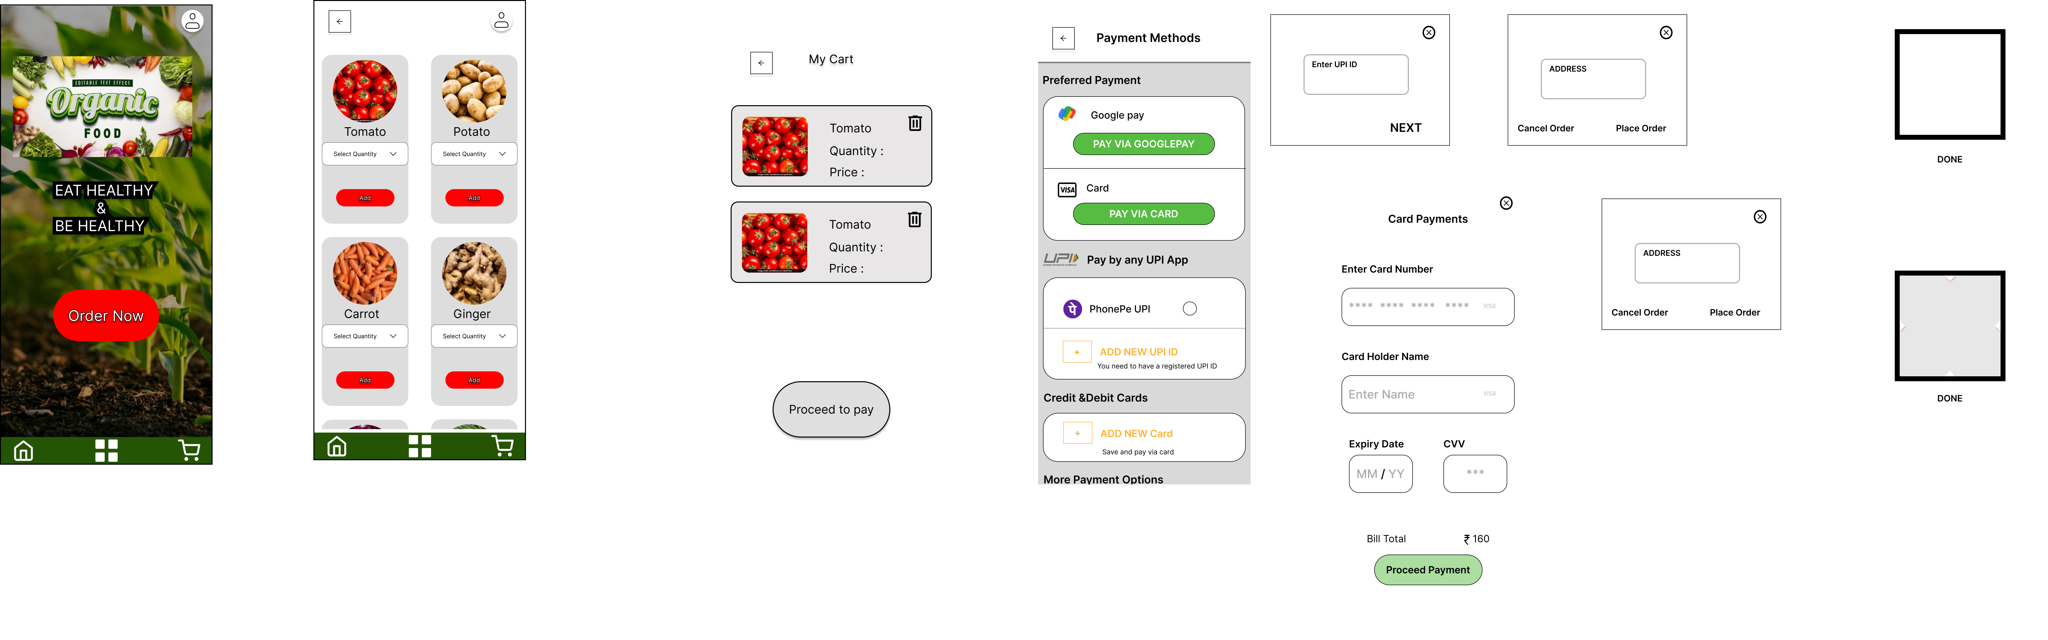

By clicking the order now button the user will redirect to list page there he can order the items he want after he chooses some items those items will added to cart.

by clicking the proceed to pay button the user navigate to the payments page. then the user will pay by his preferred payment page after completing the transaction he will again redirect to the home page

**Figma :**

https://www.figma.com/design/0QeD2QAGsuzneeimEEfctB/Elevate-labs?node-id=59-8&t=lw1sNd598vigxdNQ-1